MY SQL-3

BY:G.SOWMYA

ROLLNO:22H51A0588

1.product details of orders10103

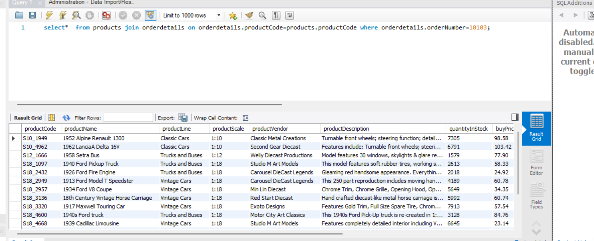

2.customer information for order 10127

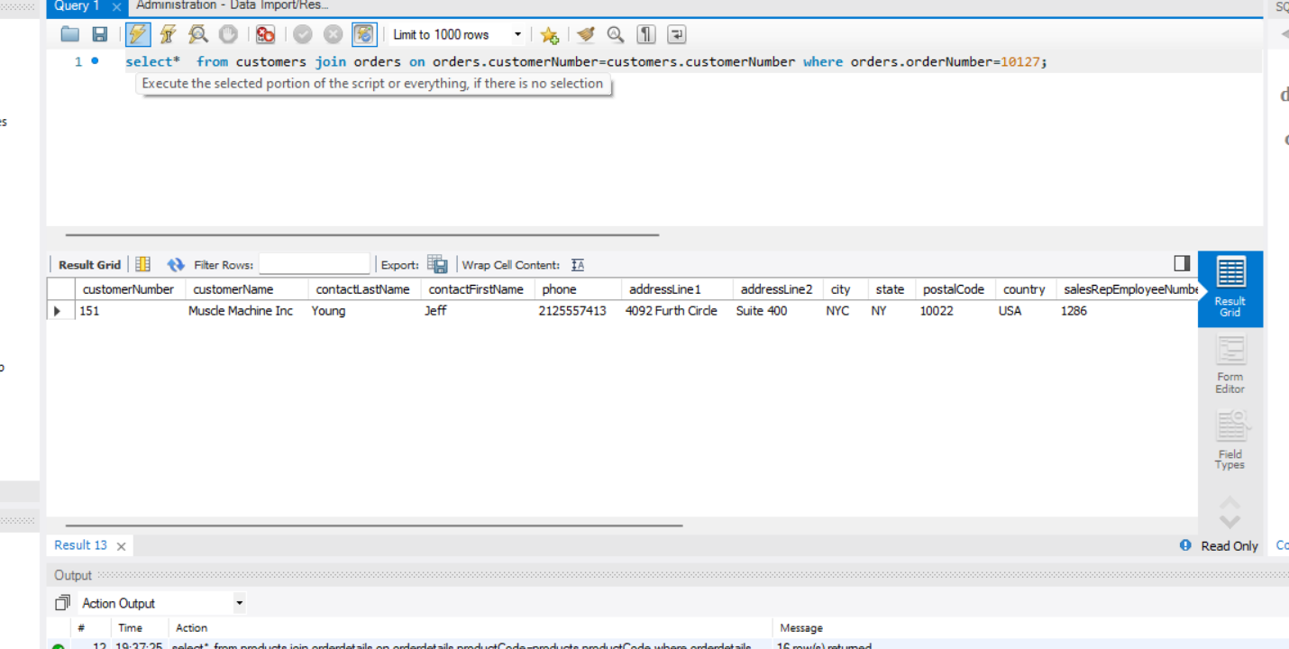

3.employee information for order166

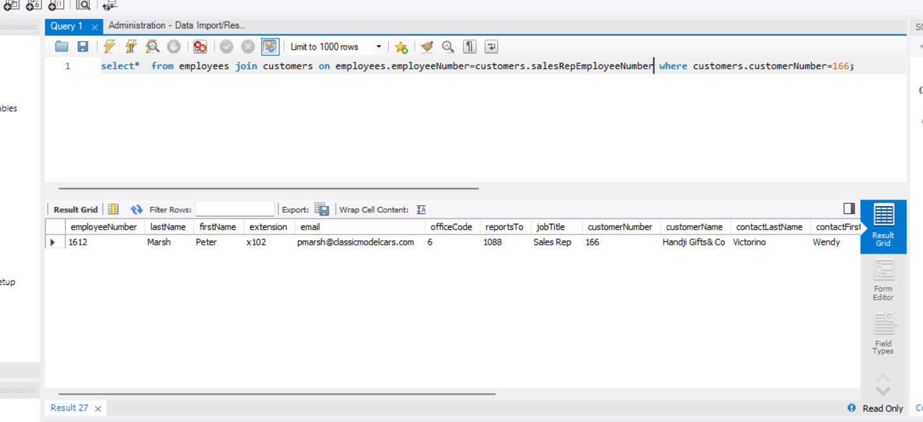

4.official information for office code4

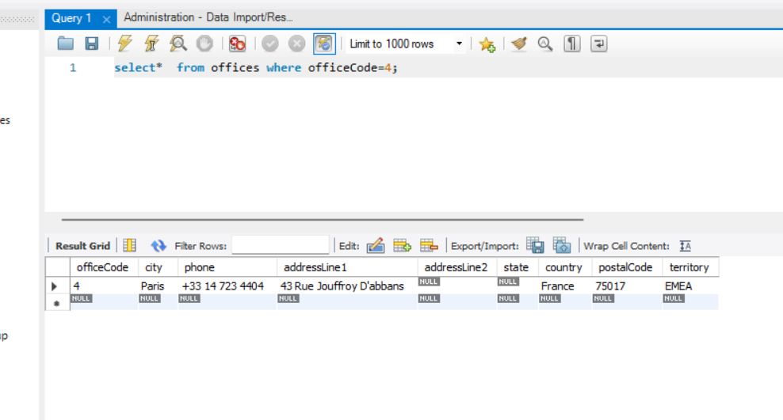

5. Product line for each product in an order

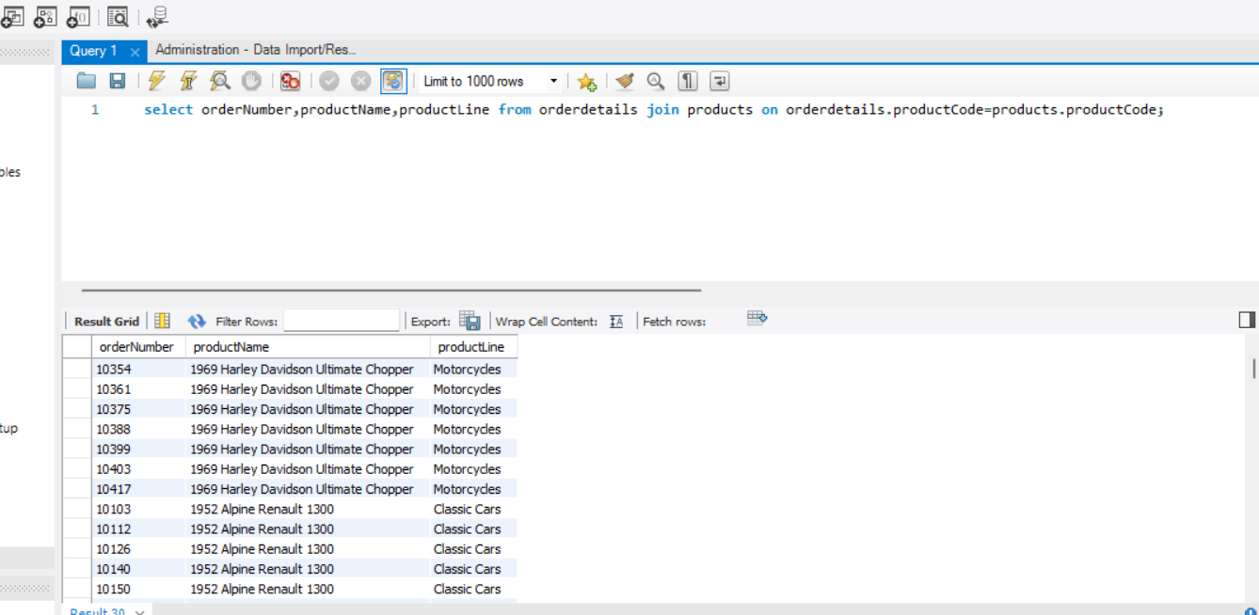

6. Customer information and order status of the product line= Classic Cars

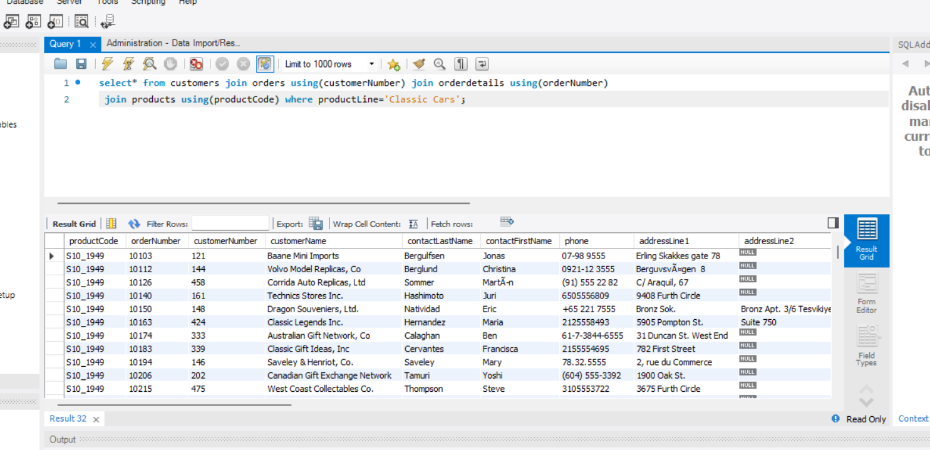

7.payment and customer details of customernumber 103

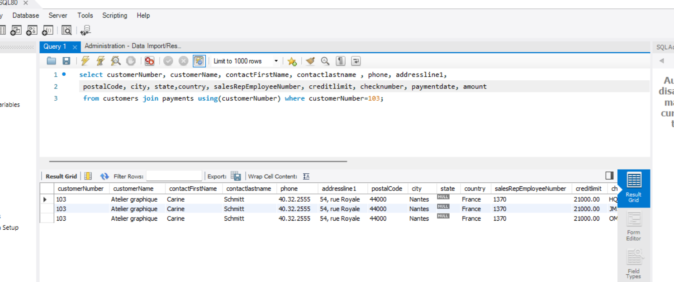

8. Orders and corresponding payments of same customer

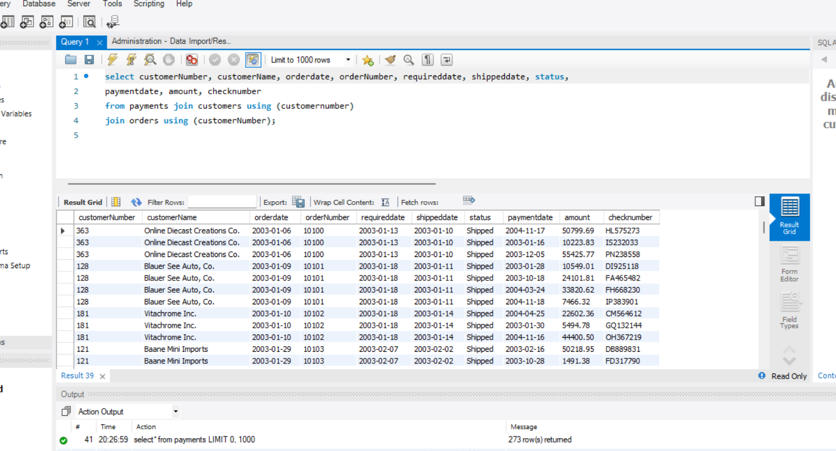

9.customers and related orders

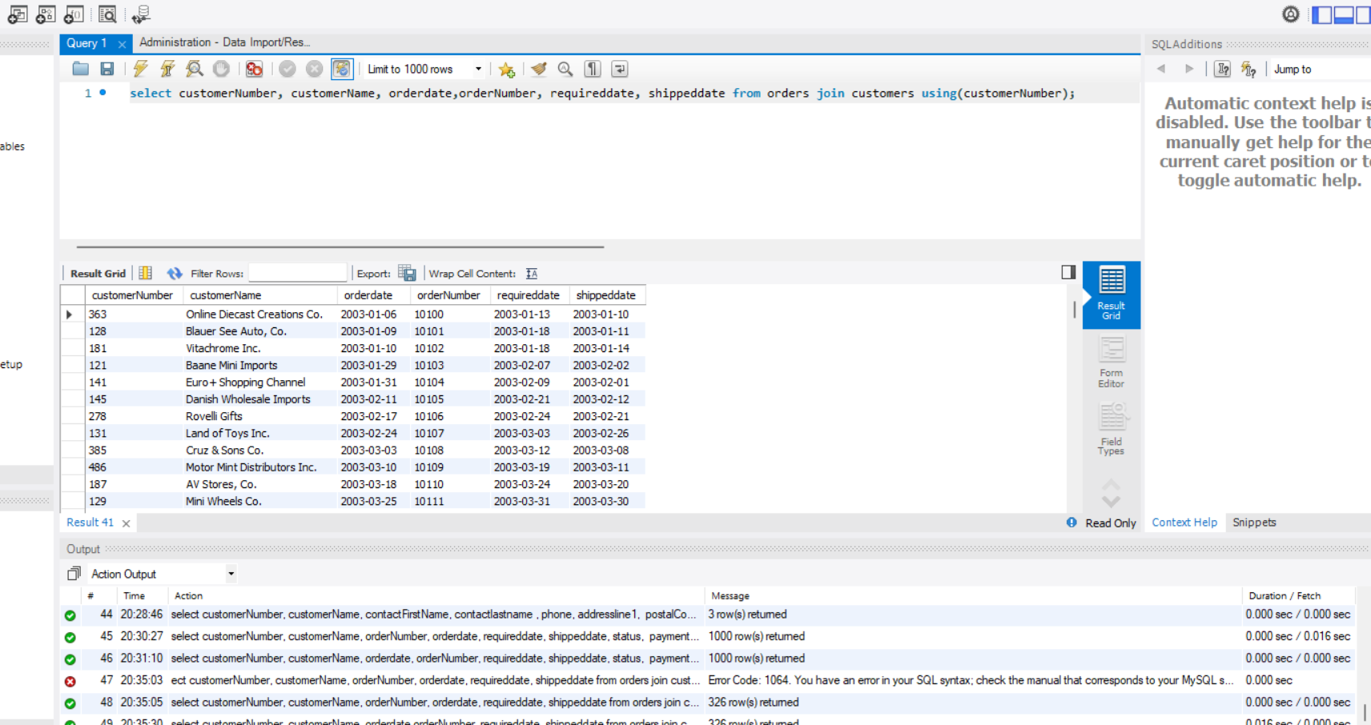

10.products and related productline

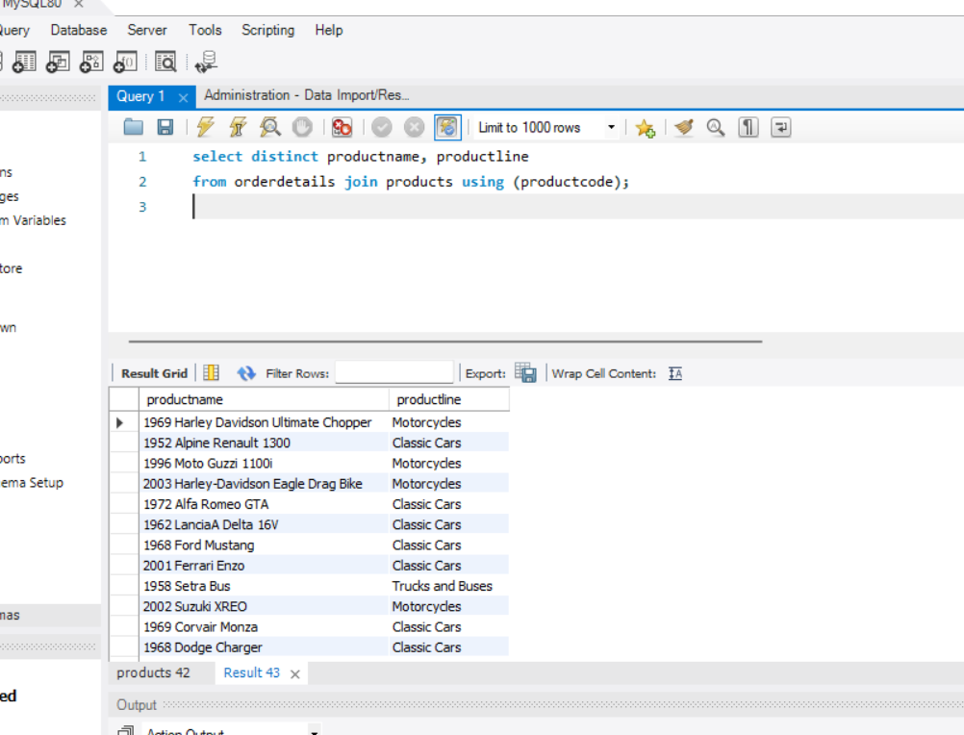

11.employee and their managerdetails

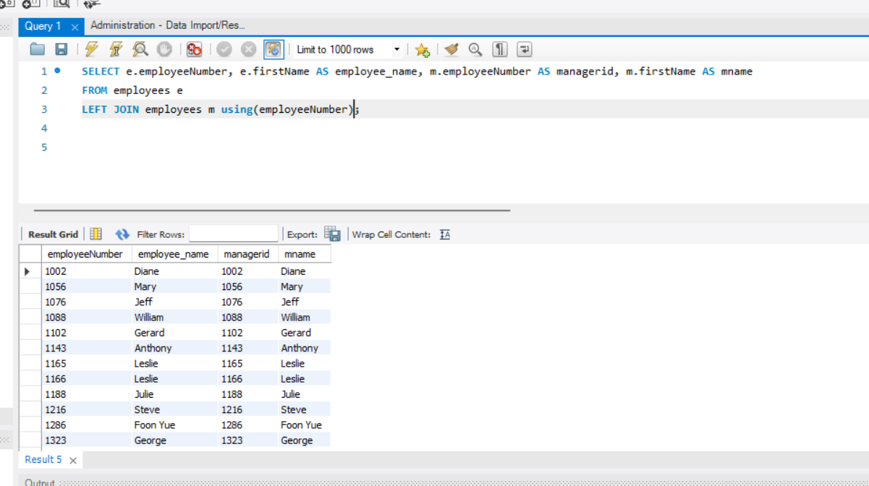

12.customer,orders and related productdetails

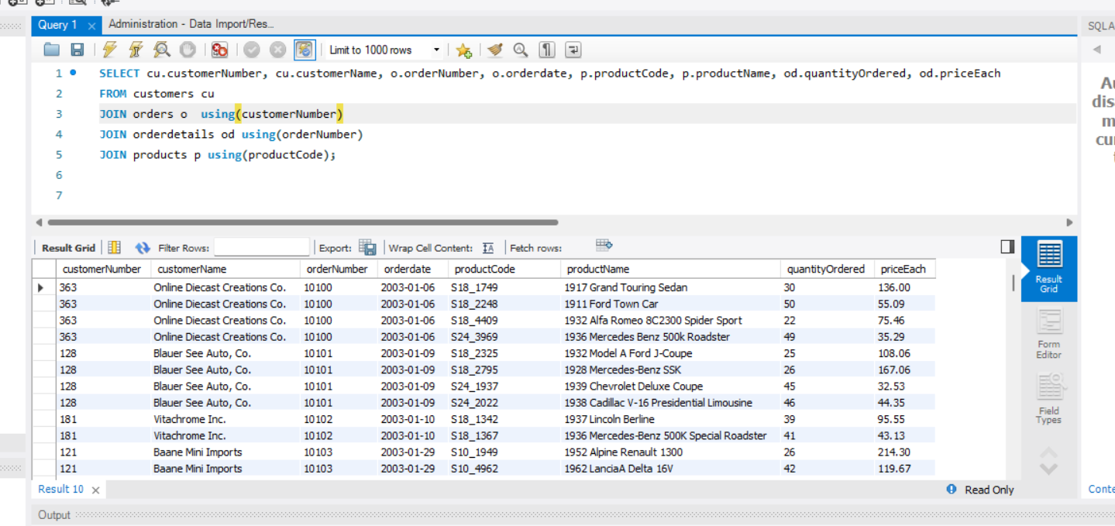

13.payment,order details for that product.

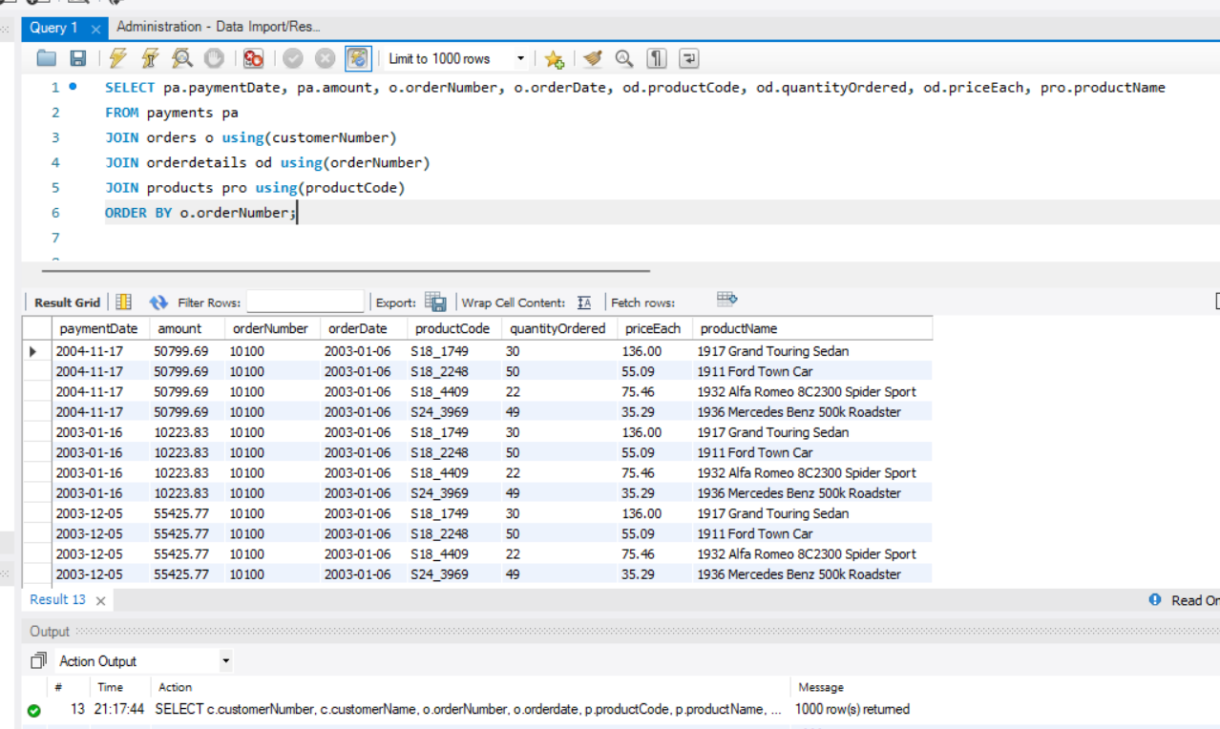

14.paymentdetails ,customer information whose cheque number-JM555205

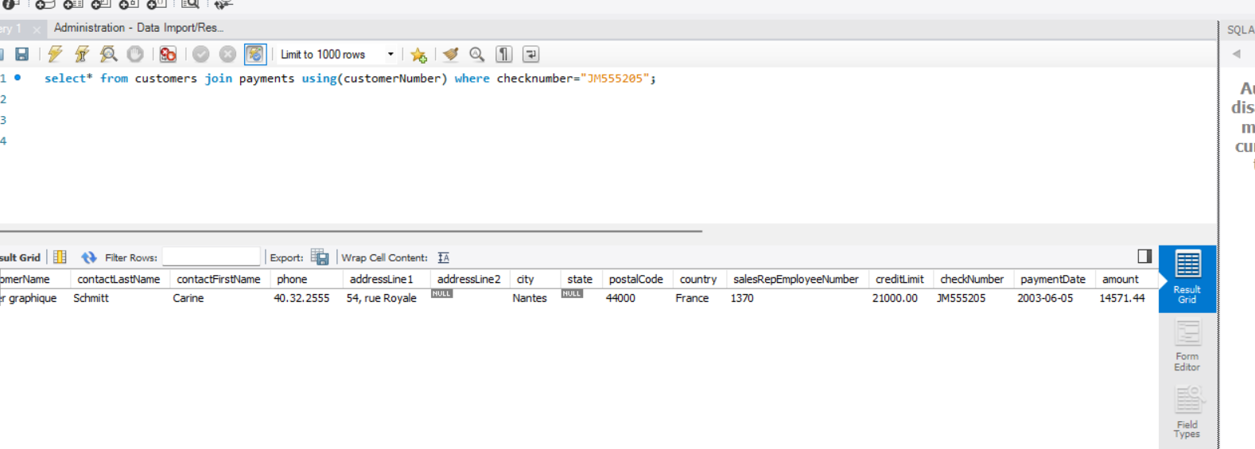

15.order,corresponding customer and employee info whose status is cancelled

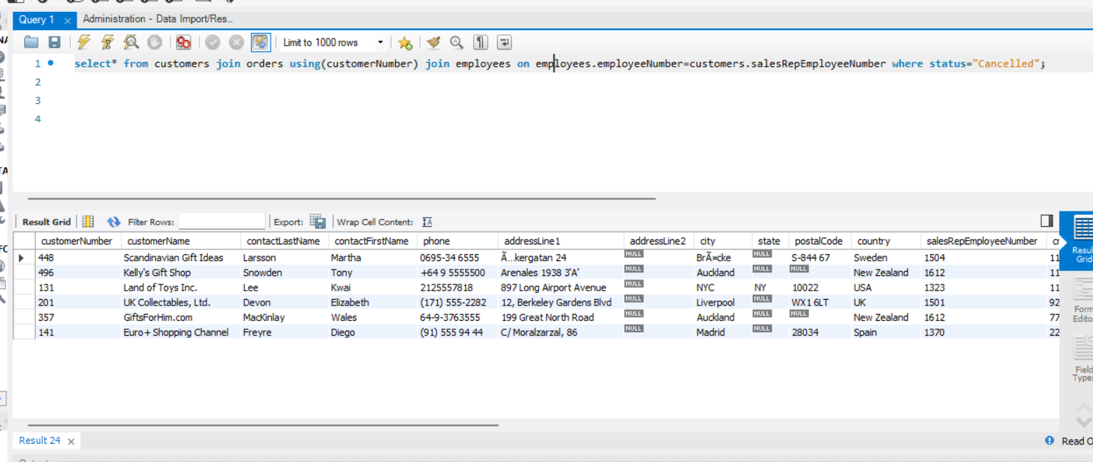

16.payment,orderdetails, related product information for paymentdate 2004-12-17

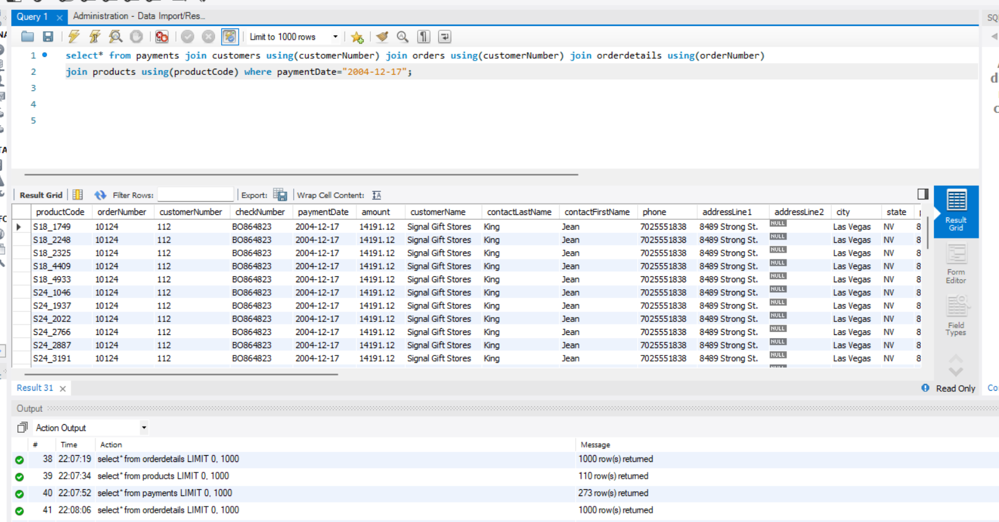

17.product,orderdetails for customernumber=112

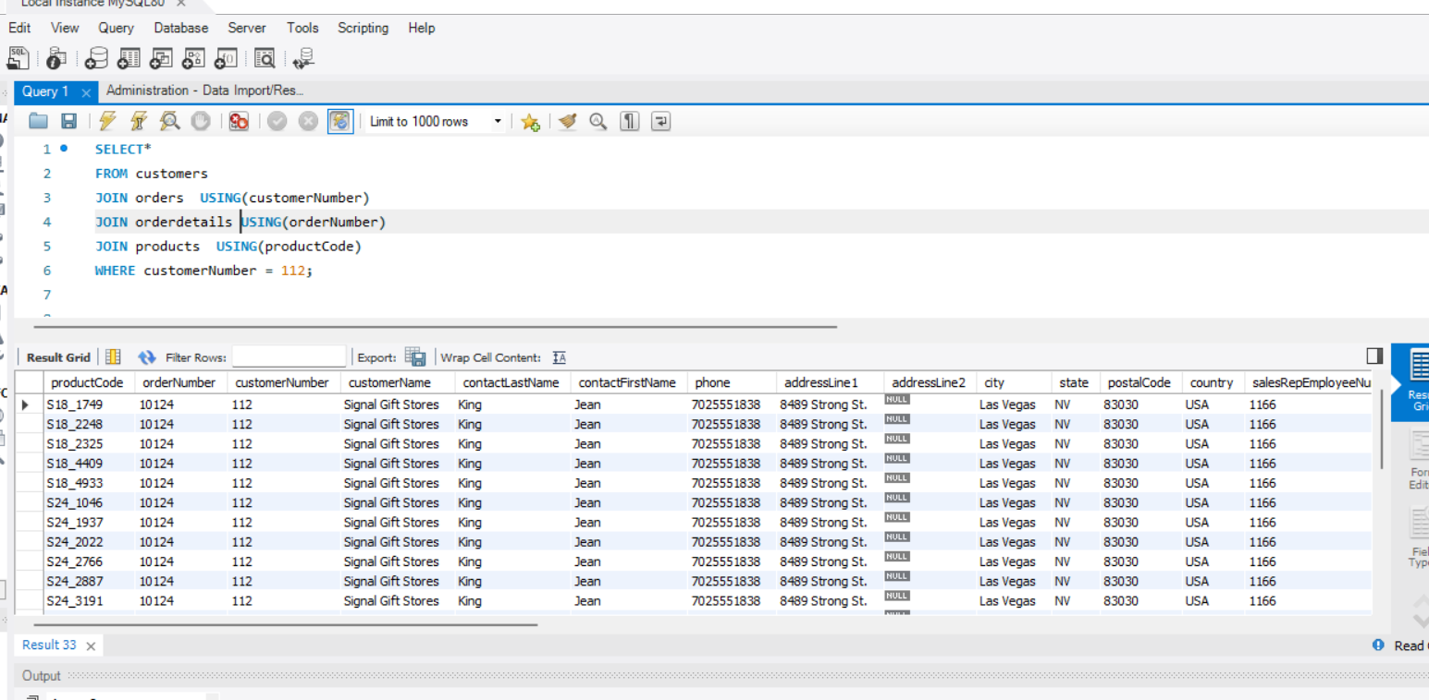

18.customers,orders,related from products from boston

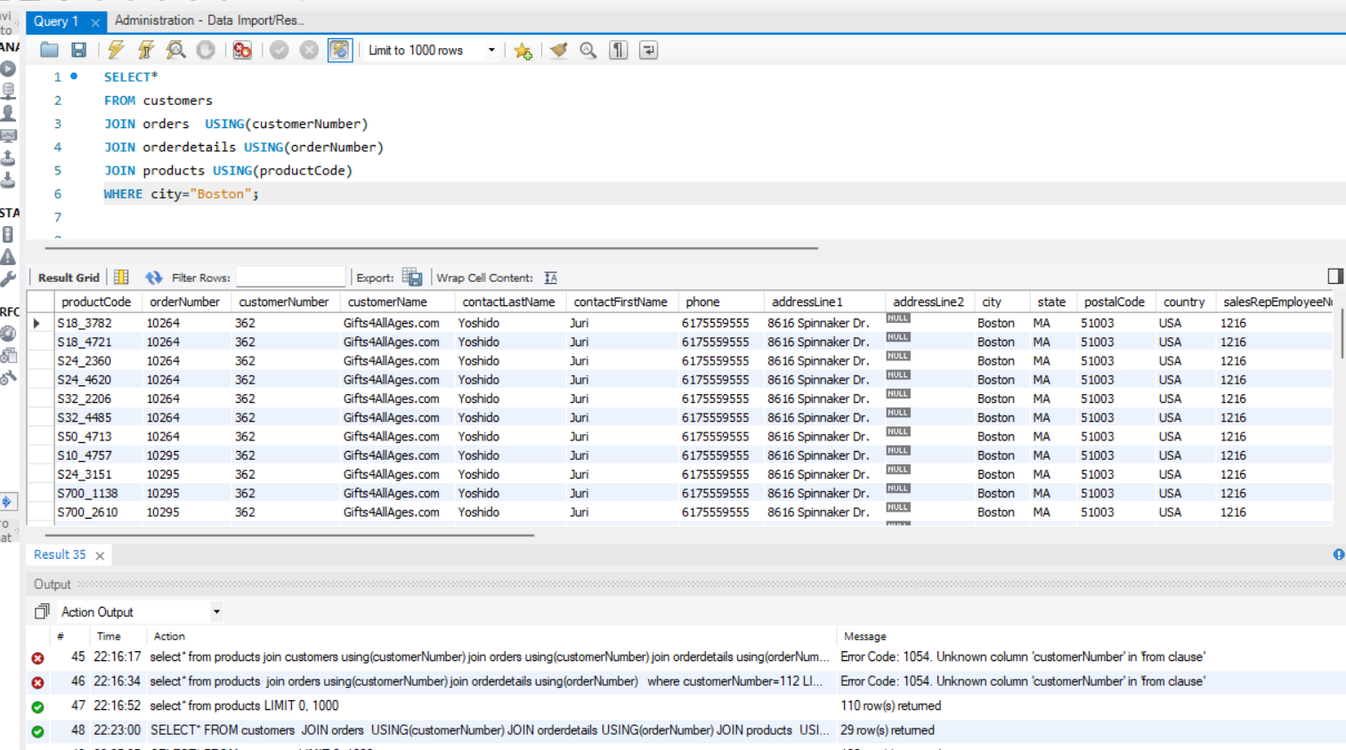

19.employees,managers,whose officedetails are salesrep

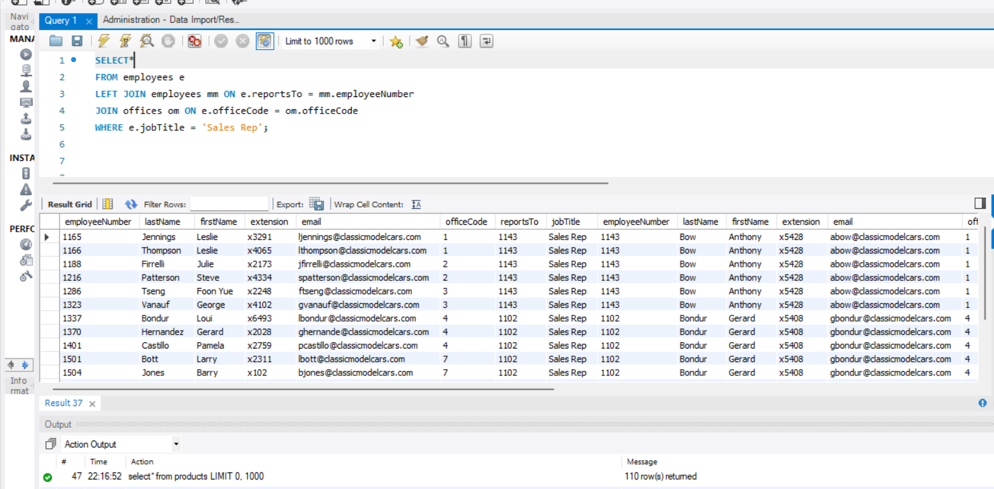

20.productlines,product related customer info for vintagecars

